APPLICATION FOR FREE LIBRARY SERVICES
 |  | For Official Use
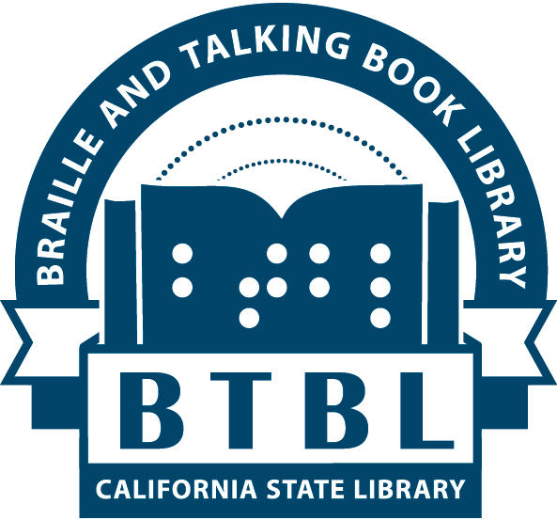 | CALIFORNIA STATE LIBRARY  Braille and Talking Book Library  P.O. Box 942837  Sacramento, CA 94237-0001  (916) 654-0640  Toll-Free 1-800-952-5666  btbl@library.ca.gov FAX (916) 654-1119

INSTITUTIONS

The Braille and Talking Book Library (BTBL) is a branch of the California State Library which cooperates with the Library of Congress, National Library Service for the Blind and Physically Handicapped. The books and equipment are provided by the Library of Congress. The California State Library directly administers the program in Northern California. Residents of Southern California are served by the Braille Institute Library in Los Angeles, which is also funded by the State Library. These services are provided without charge to all eligible readers.

(PLEASE PRINT OR TYPE)
Name of Institution

Mailing Address

City | County |  | State  CA | Zip Code
Name of Responsible Staff Person |  | Telephone
 |  | ( )
Email address (if available):

NOTICE

The information required on this application pertains to eligibility for and establishment of free library service for individuals who are blind and physically disabled.

This information is required by the Library of Congress National Library Service for the Blind and Physically Handicapped. Complete and accurate information will speed the application process.
Complete all pages and sign on page 7.

CONFIDENTIALITY

All information on this application remains confidential as outlined in California State Executive Order No. B-22-76. Institutional representatives are entitled to inspect information contained in their records during regular office hours. The Registration Clerk at the Braille and Talking Book Library, 900 N St., Sacramento, CA 95814 (916-654-0640), is responsible for maintaining this information.

ELIGIBLE APPLICANTS

See definitions under eligibility criteria on pages 8-9. In the case of reading disability from organic dysfunction, federal law requires that certification must be made by a Doctor of Medicine or Doctor of Osteopathy who may consult with colleagues in associated disciplines. Nursing homes, hospitals, and schools for the blind or physically disabled may retain the certification forms for individual applicants.
CERTIFICATION

I certify that the institution named serves persons who are unable to read or use standard printed materials because of blindness, visual disabilities or physical limitations. I further certify that the reading materials and equipment borrowed will be used by such persons only and that the institution agreement will be followed.

(PLEASE PRINT OR TYPE)

Name of Institution Administrator | Signature
Title/Position |  | Date
Name of Responsible Staff Member | Signature
Title/Position |  | Date

CHECK THE BEST DESCRIPTION OF YOUR INSTITUTION:

HOSPITAL LIBRARY LONG-TERM CARE FACILITY

SCHOOL OTHER (Specify):

CHECK THE TYPE OF SERVICE DESIRED

DEMONSTRATION COLLECTION – a sample of reading materials and equipment in order to raise public awareness and to advertise the availability of the braille and talking book services. Complete pages 1, 3, 6 and 7 of this application only.

DEPOSIT COLLECTION – a collection of reading materials and equipment used by an institution for loan to its eligible readers. Please complete all pages of the application form.

BOOK, MAGAZINE, AND NEWSPAPER SERVICES

Check the types of services your institution wants to receive:

Books recorded on digital cartridges (Includes the loan of a special digital player which is required to play our cartridges.)

Books on cassette tapes (Includes the loan of a special cassette player which is required to play our tapes.)

Braille books

Braille magazines

Downloadable audio and braille books through the Braille and Audio Reading Download service (BARD)

Movies and TV shows with descriptive narration

Number of persons unable to read or use standard printed material who will be served:

Talking-book readers ________ Braille readers _______

RETURN OF TALKING BOOK PLAYERS

Playback equipment and accessories are supplied to institutions on extended loan. If this equipment is not being used in conjunction with recorded reading material provided by the Library of Congress and its cooperating libraries, it must be returned to the Braille and Talking Book Library. AN INSTITUTION MUST BORROW OR DOWNLOAD AT LEAST ONE BOOK OR MAGAZINE PER YEAR TO RETAIN THE USE OF THE EQUIPMENT.

IF OUR REQUESTED BOOKS ARE NOT AVAILABLE THE LIBRARY MAY SELECT BOOKS FOR US.

YES (CHECK INTEREST CATEGORIES BELOW)

NO (PLEASE SEND IN A LIST OF REQUESTED TITLES FROM OUR CATALOGS)

FICTION

ADV ADVENTURE ROM LOVE STORIES
BEF BEST SELLERS MYS MYSTERIES

CLA CLASSICS SCF SCIENCE FICTION

GFI GENERAL FICTION WAR WAR STORIES

GOT GOTHICS WES WESTERNS
HIF HISTORICAL NOVELS SST SHORT STORIES

NON-FICTION

ADVNF TRUE ADVENTURES HUM HUMOR
BIO BIOGRAPHY POE POETRY
CON CURRENT EVENTS SCI SCIENCE
BEN BEST SELLERS SPO SPORTS
HST HISTORY TRA TRAVEL
HUS U. S. HISTORY WNF WAR
HUSW HISTORY OF THE AMERICAN WEST RELIGION
CAH CALIFORNIA HISTORY SPECIFY__________

CKH COOKING

OTHER SUBJECTS:

LANGUAGES: |  | ENGLISH |  | SPANISH |  |  | GERMAN |  | FRENCH
 |  | ITALIAN |  | OTHER

DO NOT select the following for us: (check as many as apply)

Books containing any descriptions of violence

Books containing any explicit descriptions of sex

Books containing any strong language

Long books

Adult reading level books

Young adult books

Juvenile books

Please indicate reading grade level (if appropriate): ________

Accessories for digital or cassette players:

Headphones

Pillow speaker (issued solely to readers confined to bed)

Accessories for use with cassette player only:

Extension levers

INSTITUTION AGREEMENT

As part of the talking book and/or braille book program, it is the responsibility of the institutional user to:

1. Return books and magazines within the prescribed three month loan period.

2. Return equipment to the Braille and Talking Book Library (BTBL) when it needs repair or is recalled by the Library.

3. Take reasonable care of equipment and materials.

4. Return materials to a mail box, the post office, or directly to BTBL.

5. Notify BTBL of address or phone number changes or equipment needing repair.

6. Abide by the published policies and procedures for BTBL service.

We understand that to retain the use of the equipment provided, we must borrow or download at least one book or magazine a year from BTBL.

We understand that failure to return materials in a timely manner may result in suspension and/or cancellation of service.

We understand the above responsibilities and agree to abide by the published policies and procedures of BTBL.

Signature of Staff Person Responsible for Institutional Service

Eligibility of Blind and other Physically Disabled Persons for Loan of Library Materials

A. The following persons are eligible for loan service:

1. Blind persons whose visual acuity, as determined by competent authority is 20/200 or less in the better eye with correcting lenses, or whose widest diameter of visual field subtends an angular distance no greater than 20 degrees.

2. Other physically disabled persons as follows:

(a) Persons whose visual disability, with correction and regardless of optical measurement, is certified by competent authority as preventing the reading of standard printed material.

(b) Persons certified by competent authority as unable to read or unable to use standard printed material as a result of physical limitations.

(c) Persons certified by competent authority as having a reading disability resulting from organic dysfunction and of sufficient severity to prevent their reading printed material in a normal manner.

B. In cases of blindness, visual disability or physical limitations, "competent authority" is defined to include doctors of medicine, doctors of osteopathy, ophthalmologists, optometrists, registered nurses, therapists, professional staff of hospitals, institutions, and public or welfare agencies (e.g. social workers, case workers, counselors, rehabilitation teachers, and superintendents). In the absence of any of these, certification may be made by professional librarians or by any person whose competence under specific circumstances is acceptable to the Library of Congress.

C. In the case of reading disability from organic dysfunction, competent authority is defined as doctors of medicine or doctors of osteopathy who may consult with colleagues in associated disciplines.

D. Qualified readers must be residents of the United States including the several states, territories, insular possessions, and the District of Columbia, or American citizens domiciled abroad.

LENDING OF MATERIALS
AND
CLASSES OF BORROWERS

A. Veterans. In the lending of books, recordings, reproducers, musical scores, instructional texts, and other specialized materials, preference shall be given at all times to the needs of the blind and physically disabled persons who have been honorably discharged from the Armed Forces of the United States.

B. Institutions. The reading materials and sound reproducers for the use of blind and physically disabled persons may be loaned to individuals who qualify, to institutions such as nursing homes and hospitals and to schools for the blind and physically disabled for the use of such persons only. The reading materials and sound reproducers may also be used in public or private schools where disabled students are enrolled; however, the students in public or private schools must be certified as eligible on an individual basis and must be the direct and only recipients of the materials and equipment.

Revised 5/15

Braille and Talking Book Library Free Matter for the Blind
P.O. Box 942837 & Physically Handicapped
Sacramento, CA 94237-0001

Braille and Talking Book Library

P.O. Box 942837

Sacramento, CA 94237-0001

